Good Shepherd Nursery School
Holiday List
2021/2022
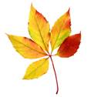

October /November – 28^{th Oct} 5th Nov (inclusive)

December - 23rd December - 5th January (inclusive)
February – 14th – 18th inclusive

March - 17th & 18th

April – 15^{th -} 25st inclusive

May – 2nd – 3rd

June – 2nd – 7th inclusive

