**Personal, Social & Emotional Development**

* Refer back to conversations we had in January about New Year and fresh starts. Making changes, out with old habits and in with new resolutions.
* Encourage the children to talk about Chinese food? Do they like it? If so,what is their favourite, discuss Chinese take-out food ?
* Would you like to go to china one day and see the celebrations themselves?
* Talk about fortune cookies, what would be a good fortune ? Share an “Imaginary Chinese meal with their friends in house corner and Chinese role play area.

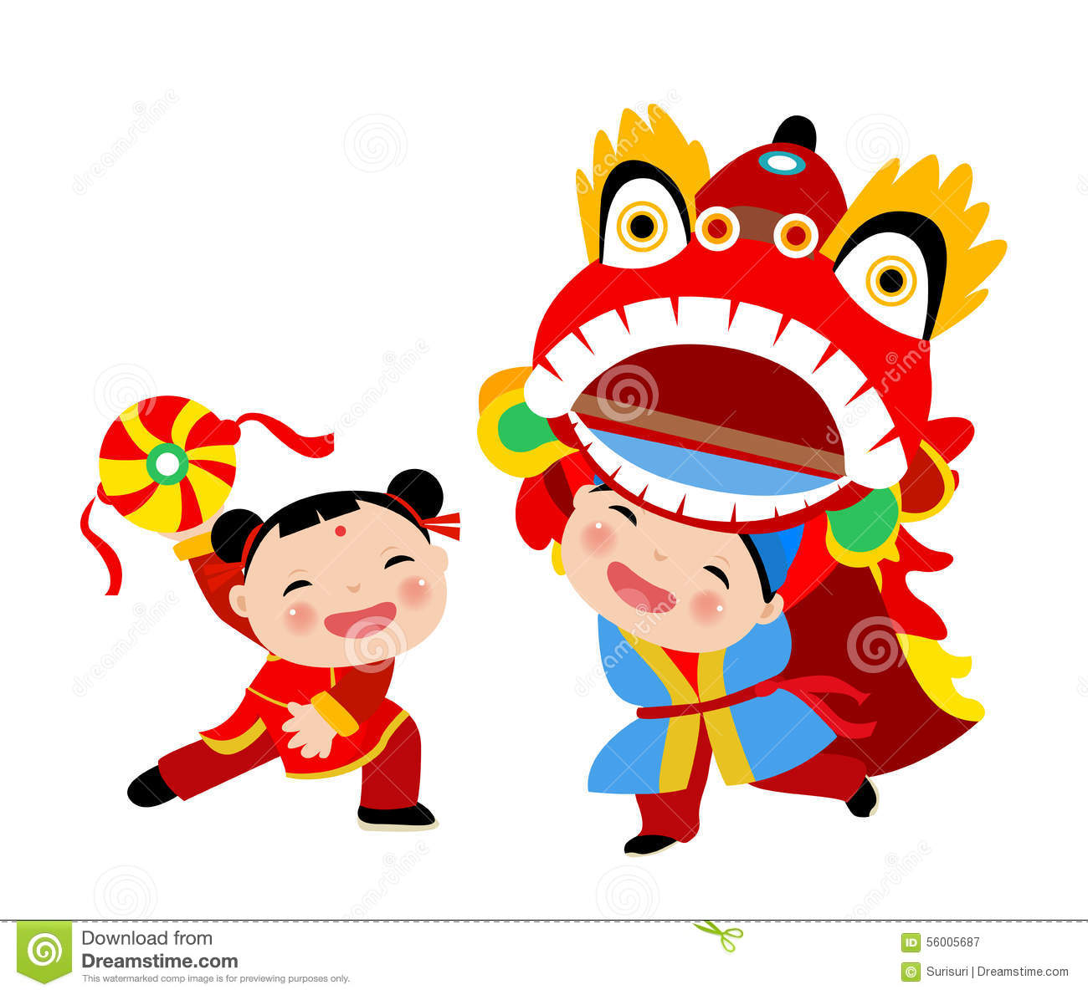

**Early Language**

Source books,videos and activities relating to Chinese culture ,

Go to Library(Ni libraries) and look for fiction books and non fiction books about China and the Chinese New Year. Discuss the lives of people that live there. Use Chinese calendars to Look at the writing and how it differs from our writing. The shape and direction of writing Write names in Chinese.

**New Language –** China, Good fortune, festival, lanterns, fortune cookies, Dragons Cultural dress .

Use books and internet to learn about Chinese life, food, jobs and traditions.

Set up sensory tray using noodles and rice. Use descriptive words to describe the experience. Soft, Long, Wiggly. Look at some animals from China, create learning opportunities and experiences using pandas.

Share the “Willow pattern” story and look at the images on blue china plates.

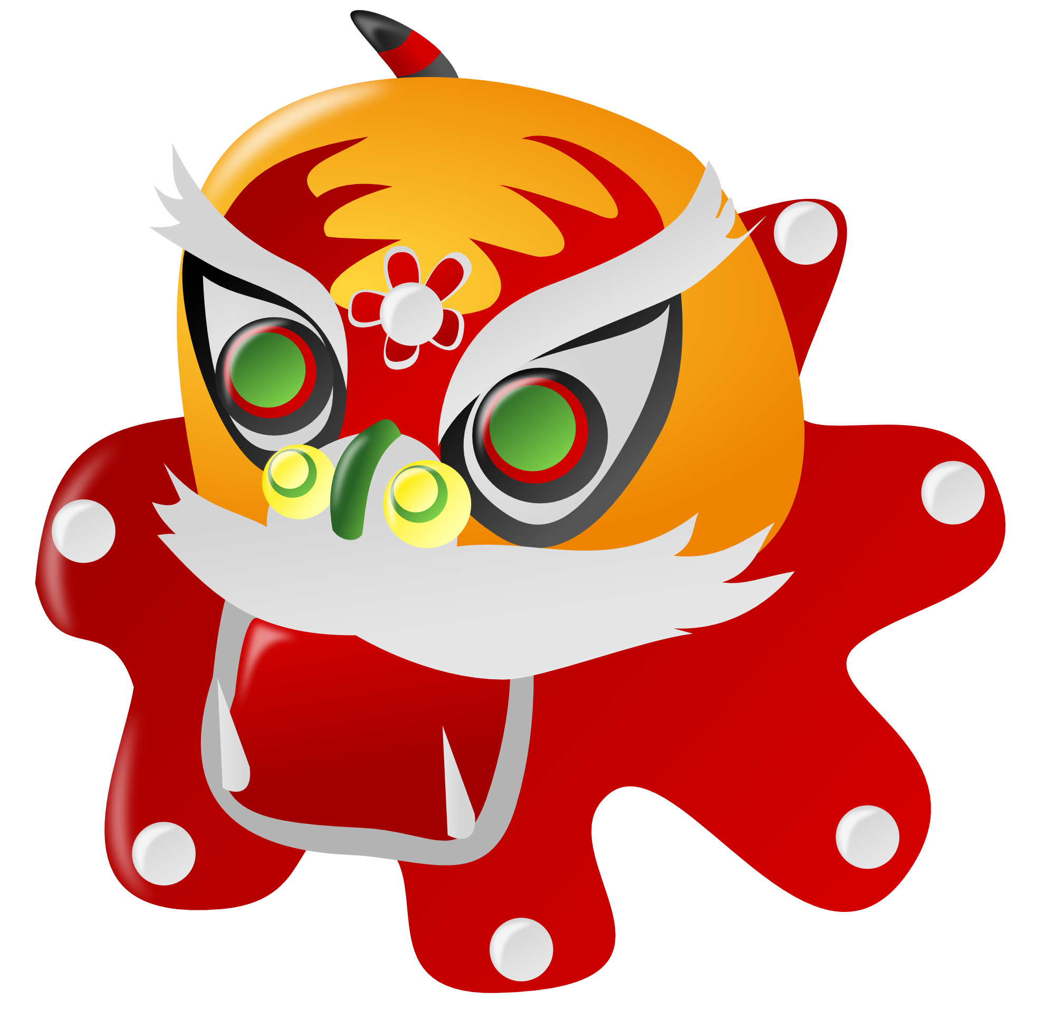

**Physical Development**

* Make a paper chain Dragon (thread, stick) Make a Dragon head out of a box and add an old sheet decorated with Chinese symbols and marks. Hide under it and dance to music or with other play instruments. Work with friends/family to make the dragon move around. Transfer pom poms using chop sticks and tongs.
* Give the children opportunities in Sensory play with cooked noodles/rice. What do you think of them? Try eating with chopsticks. Using string as noodles

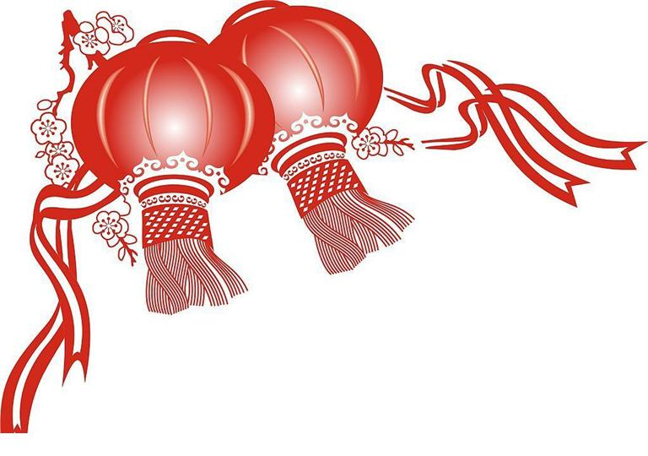

**The Arts**

* Set up some small world play with toy panda bears, bamboo,
* blocks of wood, artificial Japanese maple leaf. Make Chinese handdrums using a stick, paper plates and ribbons/pipe cleaners with beads on. Listen to Chinese music and instruments. Dance and join in with different types of movements/instruments
* Make Chinese blossoms painting. Fold origami, paper fortune cookies and lanterns. Add Chinese and utensils to house corner.
* Source Dragon dance performances on line.
* Create Art work connected to Kim in Media Initiative, share stories and messages.

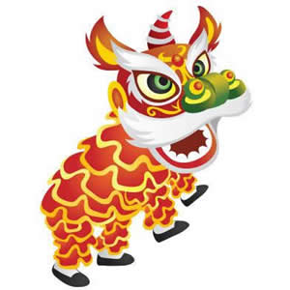

**Maths**

Allowing children to sort, match,count,correspond, sequence order in chinese roleplay area. Play a game- Where you have a plate of pom poms and chopsticks or tweezers. See how many you can get into your dish using chopsticks using a timer to record time,count to see who has the most?.

Set up a salt/sand tray and use a brush to make chinese number, symbols in the sand. Add a guide of images of the symbols and their corresponding English number.

Compare the order lengths of noodles.

 

**The World Around Us**

Use books and internet to learn about Chinese life, food, jobs and traditions. What do you think of the foods? What do you like/dislike? Look at some animals from China ,look at what type of habitats they live in and look at where China is on our globe/map/

* Look online to learn about the meaning behind some of the food eaten over the New Year celebrations.
* Look at the dances and parades that happen. Chinese Dragon Dance.Make red money envelopes, look at Chinese currency.Allow experimentation with red envelopes, gold coins and chop sticks..Use Chinese tea set in sand or water areas.
* Offer a selection of cultural themed books easily accessible in all these areas.

