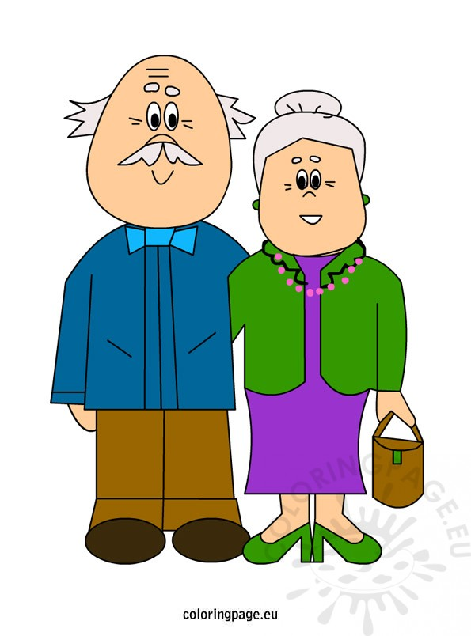 **Personal, Social & Emotional Development**

* Virtual Involvement in Grandparents day.
* Discussion and mind mapping what Grandparents do for them ?
* Showing respect to Grandparents especially now during closures.
* Are children seeing their grandparents?
* Using Grandparent puppets in role play situations.
* Virtual Stories about grandparents and their love

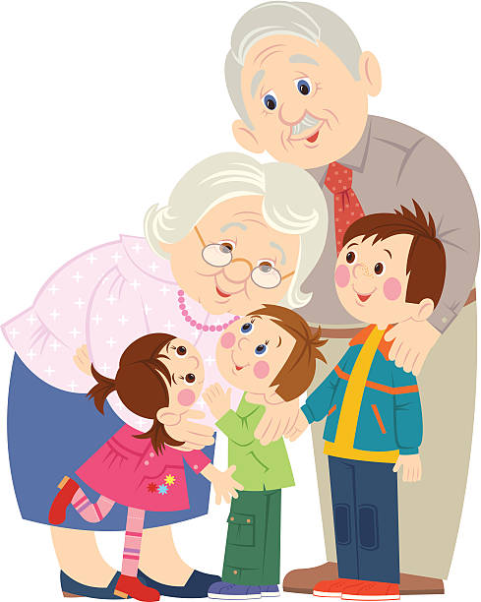 **Early Language**

* Selection of Grandparents songs and grandparent stories.
* Function wheel/Syllable card to clap out syllables using connected language.
* The preparation for and celebration of Grandparents day
* New language associated with this topic.

 **Physical Development**

* Mimicking how old people/young people move
* Links with Jump, Jiggle and Jive to explore similarities and differences.
* Discussion on games/outdoor rhymes that grandparents played
* Encourage grandparents & parents to teach “old” games, ring games to their children

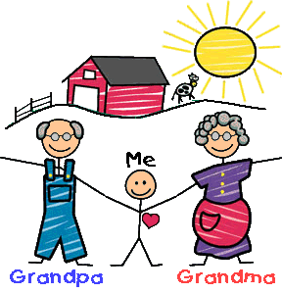**The Arts**

* Painting/drawings of Grandparents
* Poem and picture sent via seesaw.
* Teaching songs for Grandparent’s day celebration.

 **Maths**

* Measuring, counting, weighing ingredients for baking cakes etc for Grandparents week.
* Explaining the passage of time child-mother/father-grandparent
* Mathematical language old, older, oldest, young, younger, youngest.
* Estimating ages of grandparents
* Counting number of grandchildren
* How many grandparents do you have?

**T he World Around Us**

* Making a display /pic-collages of photographs of grandparents who collect or drop off children
* Slide show of Grandparents -Catholic School Week Celebration
* People who help us –ICT software.,