**Language Development**

Using vocabulary -babies, small, young, crying, nappies, dummies, bibs, baby food, cots, baths, water, baby bath…

Discussion about babies and their needs using books other children experiences, watching DVD’s. activities on interactive whiteboard

Discussing facial expressions and how babies make their needs known.

**The world around us**

Playing with babies in water tray/bath/sink- washing and cleaning, adding bubble bath, noticing level of suds/foam/bubbles and changes of colour. Watching colours of bubbles.

Adding sponges and experimenting with properties, how much water does it hold, how much can you squeeze out?

Hygiene- Important to change nappies- babies need help from parents.

Awareness of growth, babies /children/adults.

Using pink dough to make baby shapes

**Personal/Social/Emotional Development**

Showing love and care to babies, singing, hugging, bouncing and cooing.

Discussing what babies can and cannot do,how are they different from us

Relating babies to their own personal experiences- new babies in their house

Stories about babies

Taking part in washing baby in school/home, Holding them the correct way, washing and drying babies carefully

**Early Mathematical Experience**

Counting babies dummies/nappies/bowls/spoons

1-1 correspondence

Recognising colours/shapes of baby items

Comparing sizes of babies/nappies etc.

Recognising patterns in baby’s clothes

Relationships

Understanding passage of time from baby to adult

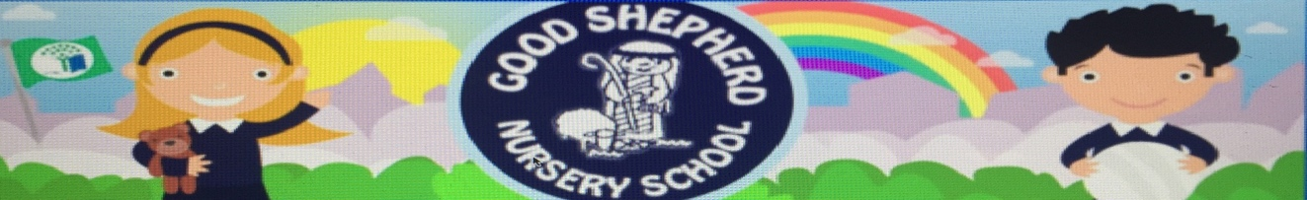

February 2021

Baby Clinic/area

**The Arts**

Drawing and painting babies.

Sticking/sorting baby items/cutting out items related to babies

Printing with dummies/bottles/baby brushes

Singing baby songs/lullabies and experiencing the rocking motion babies enjoy-feeling the pulse/rhythm

Role play in house area. baby clinic area

**Physical Development and Movement**

Putting nappies/clothes on and off dolls/babies, buttons/poppers and zips.

Wrapping babies in blankets- putting them into cot.

Washing babies carefully

Discussing the different movements that babies make

How do babies move?