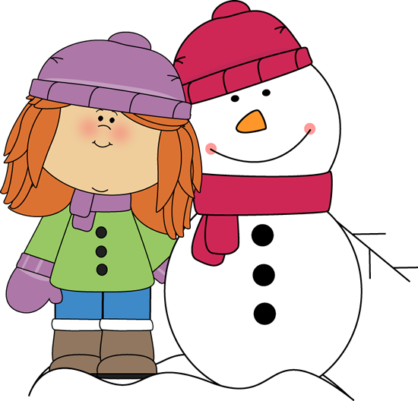
Winter Poems

Cold Snowman.
Out in the yard, I saw a snowman
Who was cold could be.
I gave him a hat and a bright red scarf
But he still looked cold to me.

So I built a big bonfire
To last through the night.
But in the morning
He was no-where in sight!
Jean Warren.
A Funny Little Snowman
A funny little snowman
Had a carrot nose.
Along came a rabbit
And what do you suppose?
That hungry little rabbit
Looking for his lunch,
Ate that snowman’s nose
With a crunch, crunch, crunch

Snow Stamping
Sometimes the snowflakes
Fall from the sky
(make fluttery downward movements with fingers,high to low)

They look like a carpet
So smoothly they lie.
(Spread open hands outwards over an imaginary smooth surface)

I put on my wellies,
Then here’s how I go…
(mime putting on both boots,then prepare for action)

Stamping my footprints
Right into the snow.
(Stamp out footprints in rhythm)

Poor Old Snowman

Poor old snowman
Standing through the night
(stand like a snowman)

He looks so cold
In his chilly coat of white.
(Hunch shoulders and rub hands together)

Up comes the jolly sun
Spreading warmth around
(make a big circle in the air with both hands)

Poor old snowman’s
A puddle on the ground.
(make original snowman shape and melt gradually down to lie on the ground)
Tony Mitton

Winter Fingerplay.

Climb, climb, climb-up the hill of snow (let fingers walk up arm)
Jump on our sleds-down we go. Weeeeee! (let fingers slide down arm)

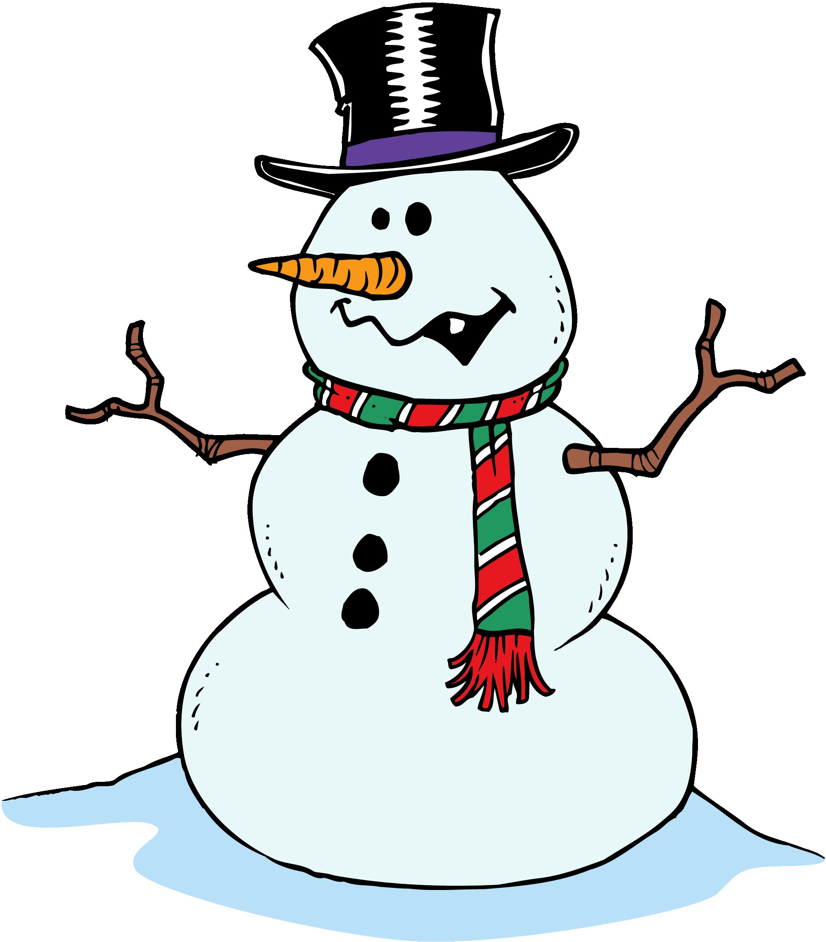
I will build a snowman

I will build a snow man.
I’ll make him big and tall,
Then I’ll try to hit him
With a big snowball.

Adapted Traditional.

Snowflakes
See the pretty snowflakes,
Falling from the sky;
On the wall and housetops
Soft and thick they lie.

On the window ledges,
On the branches bare;
Now how fast they gather,
Filling all the air.

Look into the garden,
Where the grass was green;
Covered by the snowflakes,
Not a blade is seen.

Now the bare black bushes,
All look soft and white;
Every twig is laden,
What a pretty sight!
I’m A Little Snowflake.
I’m a little snowflake, small and white.
When the moon is shining
I’m sparkly and bright.
When you see me falling,
Come out and play.
You can make a snowman with me today!

I’m A Little Snowman.
I’m a little snowman, round and fat,
I’ve got a woolly scarf
And a little bobble hat.

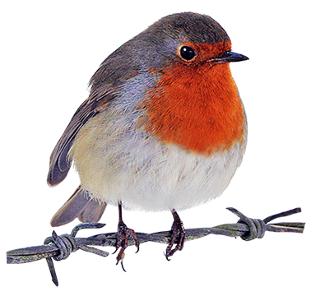The Robin.
Who’s that tapping on my window pane,
It’s a little bird and I don’t know his name.
It’s a little Robin redbreast in a waistcoat of red,
I’ll give him some nuts and a nice piece of bread.
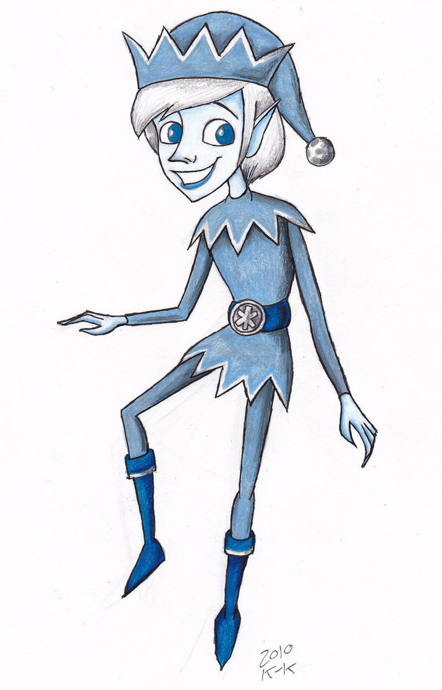Jack Frost.
Look out, look out
Jack Frost is about
He’s after your fingers and toes.
He creeps around at night
Making everything white,
And where he hide’s nobody knows.

A Chubby Little Snowman.
A chubby Little snowman
Had a carrot for a nose;
Along came a rabbit
And what do you suppose?
That hungry little bunny, looking for his lunch
Ate the snowman’s carrot nose-
Nibble,nibble,CRUNCH!

Five Little Snowmen Fat.
5 little snowmen fat
Each with a funny hat
Out came the sun
And melted one,
Oh,how sad was that.
4,3,2,1.

A snowman stood on a Snowy Ground
A snowman stood on a Snowy Ground
Five little children danced around
One fell down with a BUMP on the ground
How many left to dance around?

A snowman stood on a Snowy Ground
Four little children danced around
One fell down with a BUMP on the ground
How many left to dance around?
(Continue until none are left)

The North Wind
The north wind doth blow,
And we shall have snow.
And what will poor robin,
Do then, poor thing?
He’ll go to his barn,
And to keep himself warm
He’ll hide his head
Under his wing, poor thing.
It is Snowing (Frere Jacques)

It is snowing, it is snowing,
Falling down, falling down.
Winter winds are blowing,
Drifts are slowing growing,
All around, all around.

Jean Warren.
Five Hungry penguins(Ten Green Bottles)

Five Hungry Penguins standing by the sea,
Five hungry penguins standing by the sea.
And if one hungry penguin should catch a fish for tea,
There’ll be four hungry penguins, standing by the sea.
4,3,2,1…

The Snow is Falling Down.(The Farmer in the Dell)

The snow is falling down,
The snow is falling down,
Heigh ho,fast then slow,
The snow is falling down.

The yards are covered with snow,
The yards are covered a snow,
Heigh Ho, just watch it snow,
The yard are covered in snow.
( Continue with other places the snow might fall…streets,cars,houses,me…)

Jean Warren
I’m A Little Snowman(I’m a Little Tea-pot)

I’m a little snowman
Short and fat,
Here are my buttons,
Here is my hat.

When the sun comes out,
I run away
Before, I slowly
Melt away!

Adapted Traditional
I Love Snow (Three blind Mice)

I love snow, I love snow.
Soft white snow, soft white snow.
It falls on the ground so soft and white.
Sometimes it falls all through the night.
Did you ever see such a beautiful sight,
As soft white snow?
Pretty Snowflakes(London Bridge)

Pretty snowflakes falling down,
Falling down, falling down.
Pretty snowflakes, falling down
All through the town.
Jean Warren
It Is Snowing( Frere Jacques)

Cold winds blowing, It is snowing.
But I don’t care I don’t care.
I am snug inside. I am snug inside.
Let it snow.
Let it blow.
Jean Warren.

5 Little Snowflakes
One little snowflake with nothing to do.
Along came another, and
Then there were 2.
Two little snowflakes laughing with me.
Along came another, and
Then there were 3.
Three little snowflakes looking for some more.
Along came another,and
Then there were 4.
Four little snowflakes dancing a jive.
Along came another,and
Then there were 5.

Five little snowflakes having so much fun.
Out came the sun ,and
Then there were none!

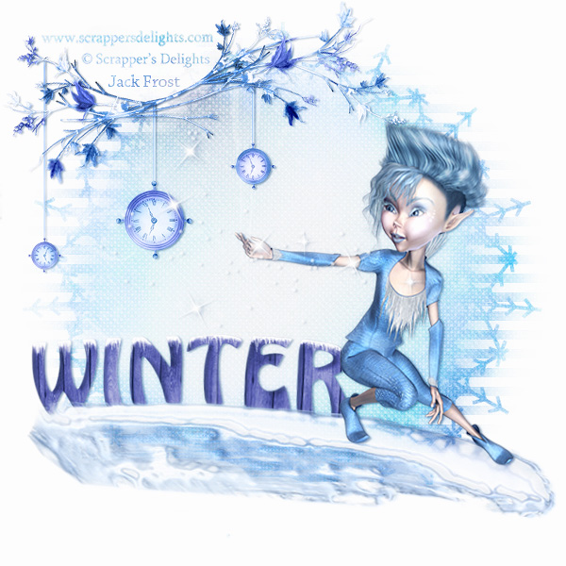
Little Jackie,Jackie Frost

Little Jackie,Jack Frost bites my nose,
Little Jackie,Jack Frost stings my toes,
Little Jackie,Jack Frost climbs the trees
Little Jackie,Jack Frost paints the leaves.

Little Jackie Jack frost thinks it’s fun
Knocking all the leaves down one by one
When the winter wind begins to blow
Little Jackie runs away, Ho! Ho!

The Snowman( I’m A little Tea-pot)

I’m a little snowman short and fat
Here’s my scarf and here’s my hat.
When the snow is falling hear me say,
Build a snowman everyday.

In The Winter Time.

In the winter time, when it’s dark and cold
We will build a lovely snowman in the garden.
With his hat and his gloves and buttons made of coal
We will build a lovely snowman in the garden.

I hope it snows all day and it snows all night
Then we can all go out in the snow and play
And we’ll run and slide and we’ll shout HURRAH
When we build a lovely snowman in the garden.

Grandparent Poems
Granny’s in the kitchen,
Doing a bit of stitching;
In came the Bogey man
And chased Granny out!
Oh! Said granny,
That’s not fair.
“Oh”, said the bogey man,
“I don’t care!”

Granny,Granny,Gray
Granny,granny gray,
Will you let me out to play
I won’t go near the water
Or chase the ducks away!
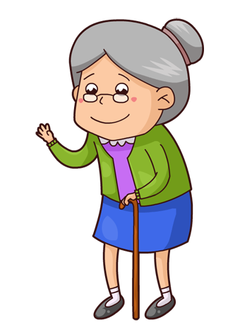

Grandma's Spectacles Original Author Unknown

These are grandmother's glasses, (makes circles around eyes with fingers)
This is grandmother's hat. (use both hands and cup on head)
This is the way she folds her hands, (fold hands)
And puts them on her lap. (put hands in lap)

These are Grandpa's glasses
This is Grandpa's hat
Here's the way he folds his arms
And THAT IS THAT!

Grandparent's Day(This Old Man)

Grandparent's Day, Grandparent's Day
Is a very special day!
With a great big hug (wrap arms around yourself)
And lots of kisses too (kiss your hand and throw it)
Each one says that I love you!

Grandma, Grandpa(Are you sleeping?)

Grandma,Grandpa…
Grandma,Grandpa…
Today’s for you!
Today’s for you!
We want you to feel special,
To know how much we love you…
Yes,we do!
Yes,we do!

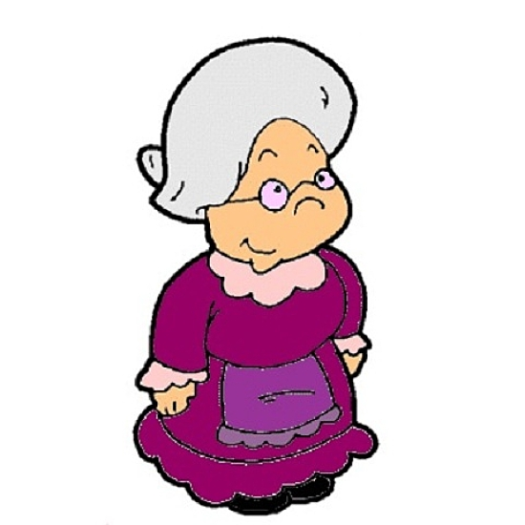Oh,you cannot throw your granny off a bus

Oh,you cannot throw your granny off a bus
Oh,you cannot throw your granny off a bus
Oh,you cannot throw your granny ,cos,she’ your mummy’s mummy..oh you cannot throw your granny off a bus!!
Singing aye,aye,yippee,yippee,aye……

Oh,you cannot throw your Granda,off a bus…he’s your daddy’s daddy…oh,you cannot throw your granda off a bus!!

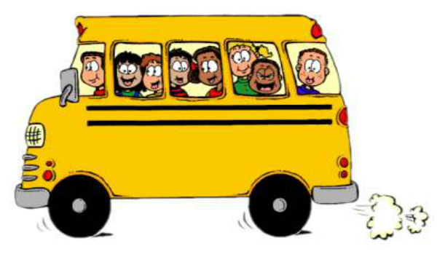
The grannies on the bus(The wheels on the bus)

The grannies on the bus go chatter,chatter,chatter
…..knit,knit,knit…..

He’s got the whole World in His Hands.

He’s got Granny’s and Grandads in his hands….

In My Family.(Polly put the kettle on)

Granny bakes delicious cakes,
Granny bakes delicious cakes,
Granny bakes delicious cakes in my family.
She is in my family,
She is in my family,
She is in my family,
In my Family!!

Granda takes me to the zoo x3
In my family.
He is in my family x3
In my family!

Happy Family Song. (Barney song)

I love you,
You love me,
We’re a happy family.
With a great big hug
And a kiss from me to you,
Won’t you say
You love me too!!

Twinkle twinkle chocolate bar.

Twinkle twinkle chocolate bar, my granda drives a rusty car.
Turn the key and push the choke
Off it goes in a puff of smoke.
Twinkle,twinkle chocolate bar,
My granda drives a rusty car.

Grandma and The Flea( A sailor went to sea)

My grandma found a flea, flea, flea,
A-swimming in her tea, tea, tea
She took a spoon and fished it out,
And gave the flea to me, me, me.

I made the flea a bed, bed, bed,
To rest his little head, head, head
But when I went to say “goodnight”
Well, this is what he said, said, said

I do not want to nap, nap, nap
I’m not a sleepy chap, chap, chap.
I’d rather dance all through the night,
And make my feet go, tap, tap, tap.

He danced all through the night, night, night,
Until the morning light, light, light.
When I woke up he winked his eye,
And hopped off out of sight, sight, sight.

My Grandma, she got up, up, up,
And made some tea to sup, sup, sup.
The flea was doing loop the loops,
And fell into her cup, cup, cup.

Down The Avenue( Tune-Michael Finnegan)- (Michael Finnegan,Tap your chinnigan,p.g 10)

Slowly
Grandpa’s strolling down the avenue,
Grandpa’s strolling down the avenue,
Grandpa’s strolling down the avenue,
Strolling down the avenue with me.
Faster
Grandma’s striding down the avenue,
Grandma’s striding down the avenue,
Grandma’s striding down the avenue,
Striding down the avenue with me.
Very fast
Grandparent’s running down the avenue,
Grandparent’s running down the avenue,

Grandparent’s running down the avenue,
Running down the avenue with me.

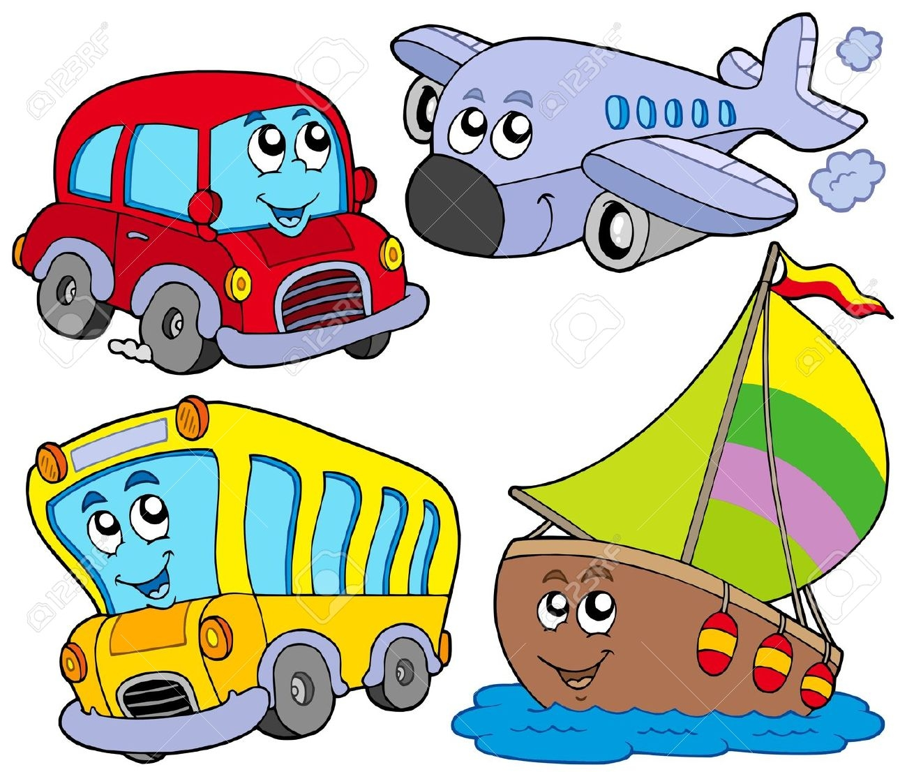Transport Poems

Rickety Train Ride
I’m taking the train to Ricketywick.
Clickety,clickety,clack.
I’m sat in my seat
With a sandwich to eat
As I travel the trickety track.

It’s an ever so rickety, trickety train
And I honestly thinkety think
That before it arrives
At the end of the line
It will tip up my drinkity drink!

The Train
The train goes running along the line,
Jicketty -can, Jicketty -can.
I wish it were mine, I wish it were mine,
Jicketty -can, Jicketty -can.
The engine driver stands in front ---
He makes it run, he makes it shunt;
Out of the town,
Out of the town,
Over the hill,
Over the down,
Under the bridges,
Across the lea,
Over the bridges,
And down to the sea,
With a Jicketty -can, Jicketty -can,
Jicketty -can, Jicketty -can,
Jicketty -can, Jicketty -can…

I Ride My Little Bicycle.

I Ride My Little Bicycle.
I brought it to the shop
And when I see the big red light
I know I have to stop!!
Ting-a-ling!Ting-a-ling!

The Big Ship sails

The Big Ship sails on the Ally-Ally-O,the ally-alley-o,the alley,alley-o
The Big Ship sails on the Ally-Ally-O, on the last day of September.
The captain says “it will never ever do, never ever do,never ever do”
The captain says “it will never ever do, on the last day of September.

The Big Ship sank to the bottom of the sea, the bottom of the sea, the bottom of the see,
The big ship sank to the bottom of the sea, on the last day of September.
We all dip our hands in the deep blue sea, the deep blue sea, the deep blue sea,
We all dip our hands in the deep blue sea, on the last day of September.

5 little men in a Flying Saucer.
5 little men in a Flying Saucer.
Flew round the world one day,
They looked left and right
But they didn’t like the sight,
So 1 man flew away……
4,3,2,1…..
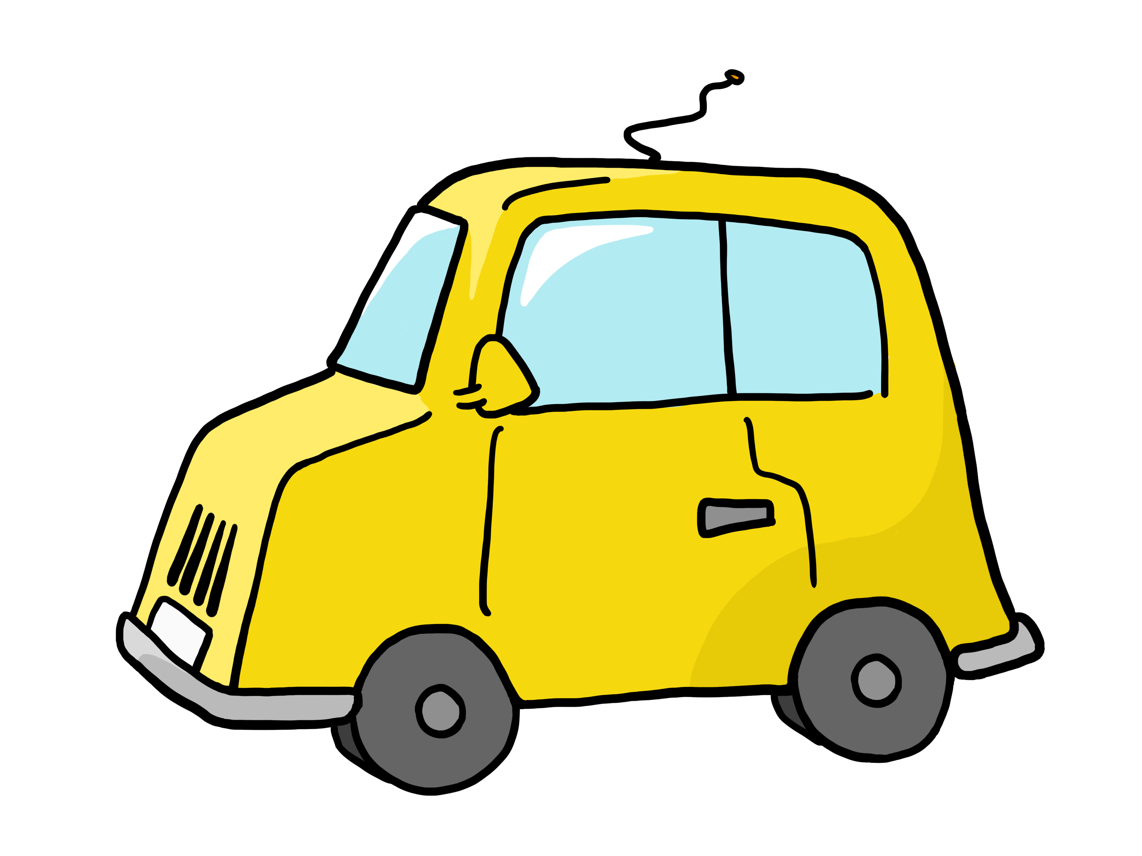Transport song (the Wheels on The Bus)

The train on the track goes, chug, chug, chug…all day long
The boat on the water goes toot, toot, toot…all day long
The car on the road, goes, beep, beep, beep…all day long.
The airplane in the sky, goes way up high…all day long.

Rusty Car.

Twinkle, twinkle chocolate bar,
My daddy drives a chocolate bar.
Push the starter and pull the choke,
And off we go in a puff of smoke.
Twinkle, twinkle, chocolate bar.
My daddy drives a Rusty car.

Down At The Station

Down At The Station, early in the morning.
See the little engines in a row.
The man inside the engine, turns a little handle,
Puff, puff, chuff, chuff, off we go!

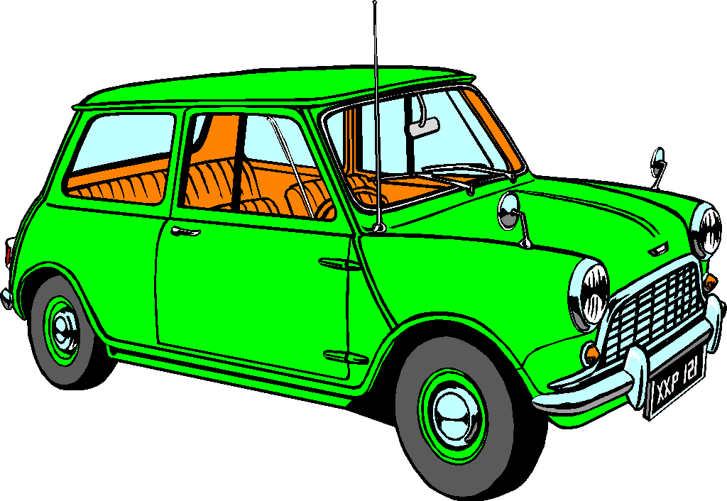Car ( Twinkle,Twinkle)

Vroom, vroom, zoom, zoom, Little car,
How, I wonder what you are.
Driving down the streets all day,
Stop then Go you never stay.
Vroom, vroom, zoom, zoom, Little car,
How I wonder what you are.

Five Little Firemen

Five Little Firemen standing in a row
1,2,3,4,5,they go.
Hop on the engine with a SHOUT
Quicker than a wink the fire is out!

Four little firemen standing in a row,
1,2,3,4,shh,they go….

3,2,1……

Stop! Look! Think! ( Three blind mice)

Stop! Look! Think!
Stop! Look! Think!
Before you cross the road,
Before you cross the road,
You must use your eyes and ears,
You must use your eyes and ears,
And if no bus or car appears
Then you can cross the road!

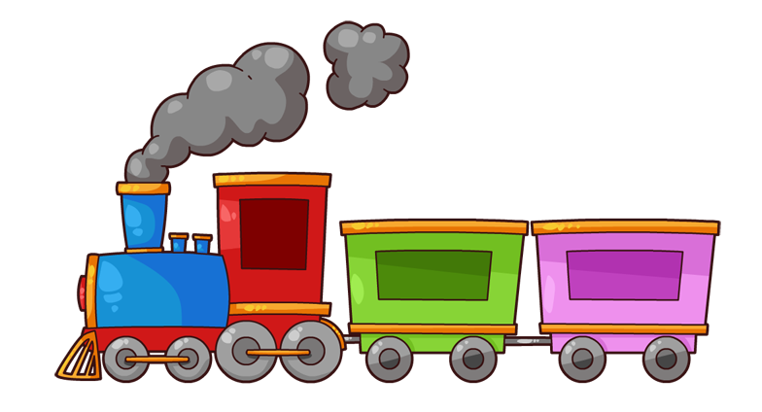

This Little Train (Skip to My Lou)

Slowly
This little train goes up the hill,
This little train goes up the hill,
This little train goes up the hill,
This little train goes slowly.

Faster
This little train goes along the top,
This little train goes along the top,
This little train goes along the top,
This little train goes faster.

Very Fast
This little train goes down the hill,
This little train goes down the hill,
This little train goes down the hill,
This little train goes racing.

Rickety Train Ride

I’m taking the train to Ricketywick.
Clickety,clickety,clack.
I’m sat in my seat
With a sandwich to eat
As I travel the trickety track.

It’s an ever so rickety, trickety train
And I honestly thinkety think
That before it arrives
At the end of the line
It will tip up my drinkity drink!

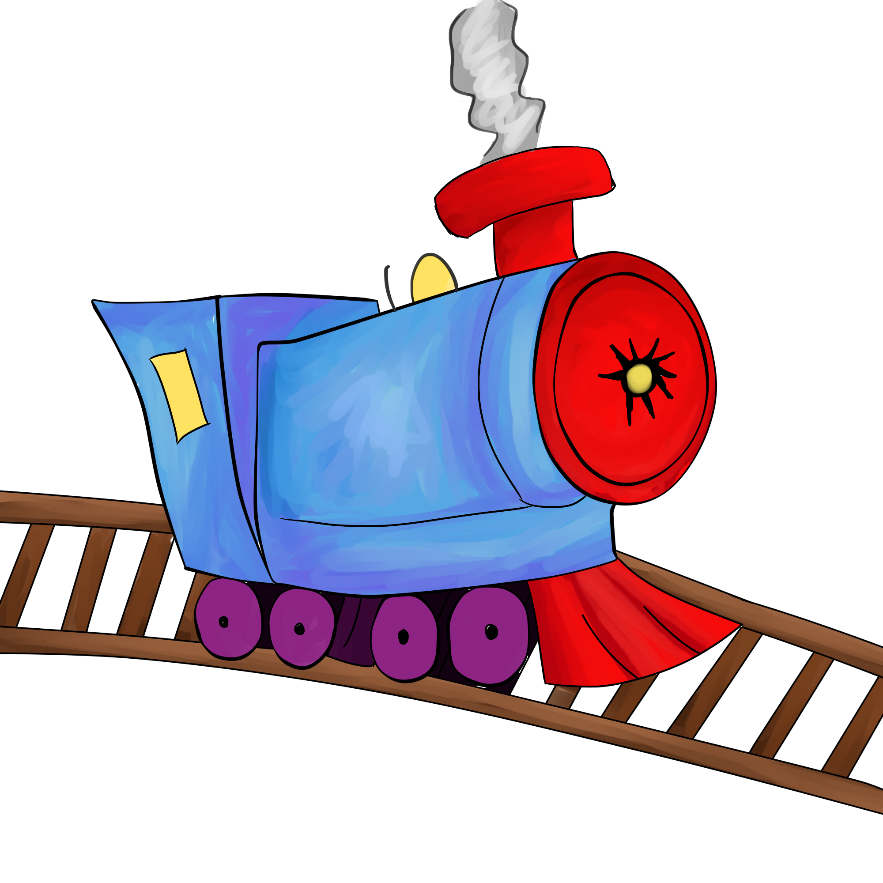

The Train

The train goes running along the line,
Jicketty -can, Jicketty -can.
I wish it were mine, I wish it were mine,
Jicketty -can, Jicketty -can.
The engine driver stands in front ---
He makes it run, he makes it shunt;
Out of the town, Out of the town,
Over the hill, Over the down,
Under the bridges, Across the lea,
Over the bridges,
And down to the sea,
With a Jicketty -can, Jicketty -can,
Jicketty -can, Jicketty -can,
Jicketty -can, Jicketty -can…
.KonaBody
Clive Sansom

Five Jolly People

Five jolly people waiting at the stop,
Along comes a bus, and one goes HOP,
Into the bus and off they go
Four jolly people waiting at the stop…….etc

I’m An Airplane ("Clementine")

I'm an airplane, I'm an airplane
Flying up into the sky.
Flying higher, flying higher
As I watch the clouds go by.
I'm an airplane, I'm an airplane
See me flying all around.
Flying lower, flying lower,
Till I land down on the ground.

I’m a little aeroplane (Frere Jacques)

I’m a little aeroplane, up in the sky.
Here are my wings, now watch me fly.
When the pilot tells me, I’ll come down.
Gently gliding to the ground.

Tune: Bingo
Look at my bright shiny car
I'm driving it today-o.
C - A - R (BEEP! BEEP!)
C - A - R (BEEP! BEEP!)
C - A - R (BEEP! BEEP!) I'm driving it today - o!
More verses:
We put on our seat belts, put the key in the ignition, got gas etc.

(Tune of Wheels on the Bus)
The wheels on the train go clackety clack
Clackety clack, clackety clack
The wheels on the train, go clackety clack
All along the track.
More verses:
The whistle... goes whoo, whoo, whoo
The conductor... says, "All Aboard"
The people ... go bumpety, bump

Train is a-coming, oh yeah.

Train is a-coming, oh yeah.
Train is a-coming, oh yeah.
Train is a-coming, train is a-coming,
Train is a-coming, oh yeah.

Better get your ticket, oh yeah.
Better get your ticket, oh yeah.
Better get your ticket, better get your ticket,
Better get your ticket, oh yeah.
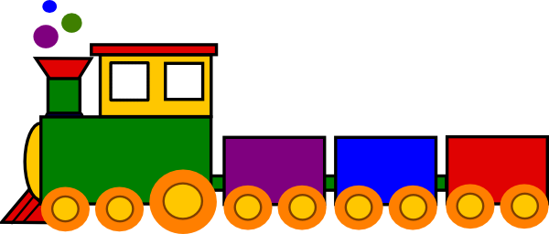

The Bus

There is a painted bus,
With twenty painted seats,
It carries painted people
Along the painted streets.
They pull the painted bell,
The painted driver stops,
And they all get out together
At the little painted shops.

Row, Row, Row Your Boat

Row, row, row your boat,
gently down the stream,
Merrily, merrily, merrily, merrily,
Life is but a dream.

Tugboat

Chug, chug, chug,
I'm a little tug.
I pull a big boat,
Chug, chug, chug.

A Sailor Went to Sea

A Sailor went to sea, sea, sea
To see what he could see, see, see.
But all that he could see, see, see,
Was the bottom of the deep blue,
Sea, sea, sea.

Bobby Shaftoe

Bobby Shaftoe's gone to sea,
Silver buckles on his knee.
He'll come back and marry me,
Bonny Bobby Shaftoe.

Bobby Shaftoe's fine and fair,
Combing down his auburn hair.
He's my friend for evermore,
Bonny Bobby Shaftoe.
Early In The Morning
Come down to the railway station early in the morning,
See all the railway trains standing in a row.
See all the drivers starting up the engines,
Clickety click and clackety clack,
Off they go!

Come down to the garage early in the morning,
See all the buses standing in a row.
See all the drivers starting up the engines,
Rumble, rumble, rumble, rumble ,
Off they go!

Come down to the seaside early in the morning,
See all the motor-boats floating in a row.
See all the drivers starting up the engines,
Splishing, splashing, sploshing, sploshing,
Off they go!

Come down to the airport early in the morning,
See all the aeroplanes standing in a row.
See all the pilots starting up the engines,
Whirring, whirring, whirring, whirring.
Off they go!
The Pirate Song

When I was one,
I banged my drum.
The day I went to sea.
I jumped aboard a pirate ship,
And the captain said to me.
We're going, this way, that way,
Forwards and backwards,
Over the Irish Sea.
A bottle of rum, to warm my tum,
And that's the life for me.

When I was two,
I buckled my shoe.....

When I was three,
I banged my knee....

When I was four,
I knocked on the door....

When I was five,
I learned to dive.....

Up Like A Rocket

Up Like A rocket (Hands in the air)
Down like the Rain (crouch down)
Back and Forward (sway backwards and forwards)
Like a choo-choo train.

Going To The Zoo On the Clickety,Cloo Train

Clickety,click,clickety click
I’m on a train and it’s going quick
Clickety cloo,clickety cloo
I’m going to London to see the Zoo
Clickety clack,clickety clack,
I’m on a train and it’s coming back.

Down At The Bus Stop.

Down At The Bus Stop
Early in the morning,
See the little children
Lined up in a row.
See the yellow school bus
Pick up all the children.
Vroom,vroom,vroom,vroom,
Off they go.

We’re Riding On The Bus(If you’re Happy)

Oh,we’re riding on the bus, on the bus.
Oh,we’re riding on the bus,on the bus.
Oh,we’re riding on the bus,
Come and ride along with us.
Oh,we’re riding on the bus,on the bus.

Repeat each time substituting a word such as “singing” or “clapping” for “riding”

Elizabeth Scofield.

We are Flying (Frere Jacques)

We are flying, we are flying,
Up so high, up so high,
See the fluffy white clouds,
See the sparkly sunshine
In the sky, in the sky.

We are flying, we are flying,
Round and round, round and round,
See the tiny houses,
See the tiny people
On the ground, on the ground,

Elizabeth Scofield

Chug,chug,chug (Jingle Bells)

Chug,chug,chug,chug,chug,chug.
Chugging down the track.
See our little choo,choo,train
Chugging down and back.
We are cars-all lined up,
Chugging just like so.
Hear our whistle toot,toot,toot
As down and back we go.

Elizabeth Scofield

Choo,Choo (from banana splits)

Once there was a choo,But he couldn’t choo,choo.
So,the story goes, instead of saying choo,choo,
All he said was achoo, because he had a cold in his nose!!
Ah…Ah… Ah…CHOO!!!
Choo,choo,choo,choo…….

January musical percussion activities-Rhythm sticks.

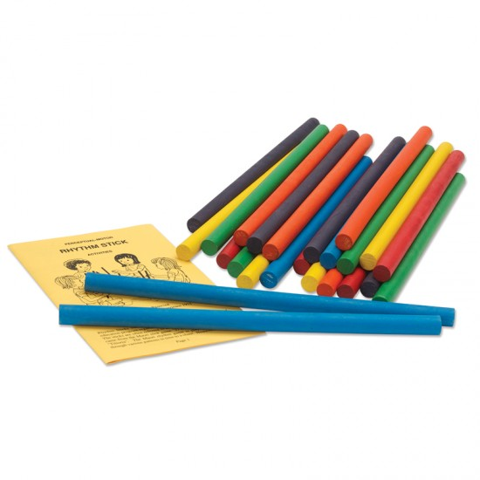
We are Tapping

We are tapping,We are tapping,
We are tapping with our sticks,
We are tapping,we are tapping with our sticks.
Additional verses.
We are scraping…
We are hammering…
We are ponding…
We are rolling….

Always emphasis the first beat, to help the children keep the rhythm more easily.(page 22 101)

Beethoven’s 5th Symphony. (p.g 32 101)

This is a very fun way to introduce children to the music of Beethoven.
The children sit in circle with a pair of rhythm sticks. Put on a recording of the opening of Beethoven’s 5th symphony. Tell the children when they hear the four note “da da da da” theme, they will tap their sticks firmly on the floor .When they hear the violins take over with high light playing, they will scrape their sticks softly.
Play the song for about a minute, then repeat it from the beginning. Children love the intense 4 note theme and “accompanying” the music of Beethoven.

Painting On The Floor. (p.g 33, 101)

Put on a soft recording of calm, soft music. Encourage the children to pretend to paint on the floor with their rhythm sticks( one or both). You can suggest they try curly lines, straight lines, circles, triangles, flowers or a smiley face, or whatever they want.

You can change the music to a different style, eg, marching, encourage them to paint the way the new music sounds.

This is a very neat way to paint—no mess!!

Tap,Tap,Tap your Boat. (P.g 34 101)

Tap to the beat while singing the following song-Row,Row,Row your boat.

Tap, tap, tap your boat,
Gently down the stream.
Merrily, merrily, merrily, merrily,
Life is but a dream.

Additional verses

Scrape, scrape, scrape your boat….
Pound, pound, pound your boat…
Hammer, hammer, hammer your boat….
Roll, roll, roll, your boat…

The Train is Coming Up The Hill (p.g 66)

Get children to play wood blocks along with, Here We Go Round The Mulbery Bush” first.Then substitute words….

The train is going up the hill,
Up the hill,up the hill.
The tain is going up the hill,
So early in the morning.

Additional verses.
The train is going down the hill…(scrape blocks while lowering them to the ground)
The train is going round the lake (scrape blocks while moving them around an imaginary lake)
The train has hit a little bump…. (on the word “bump”, clap blocks together.

Sing song fast and slow! Children love this!

Engine,Engine,Number Nine. (p.g 67)

Engine,engine,number nine,
Going down Chicago line,
If the train goes off the track,
Do you want your money back?

Adding rhythm sticks or blocks appropriately

