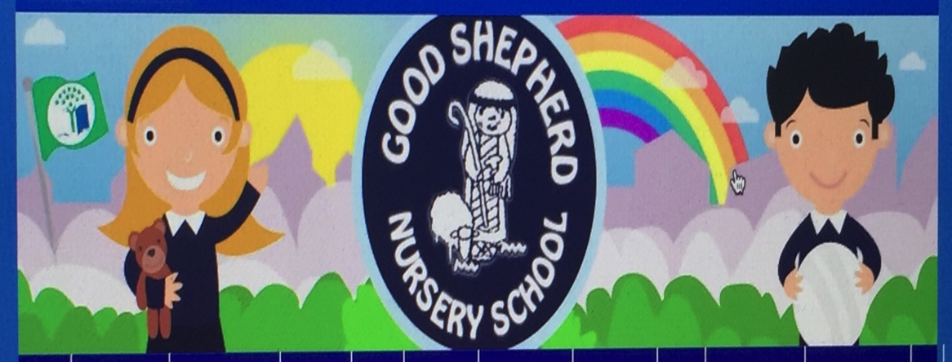
January 2021
- Experimenting with different materials (Junk Art) and resources from home and school creating wonderful pieces of art (recycling)

- Reinforcing the importance of saving energy (visual displays of eco helpers) (energy) switching off lights, closing doors. Turning off taps

- Facilitate a local artist to work with the children using different materials and techniques creating a collage of the local environment and surrounding area. Introducing the children to their environment beyond the school (hands on activity and ongoing) (biodiversity)

- Planting using old wellies creating a wonderful display for our fencing area in our “Root Shoot Buckets and Boots” garden area

- The children will make bird feeders from old pots using lard mixture and seeds. Each child to participate in this activity the bird feeder will be displayed in our garden area (biodiversity a hands-on activity with plenty of conversation)

- The children will be involved in daffodil planting, preparing our garden for springtime talking about bulbs, their shape and how to plant them right side up in our outdoor garden area.

