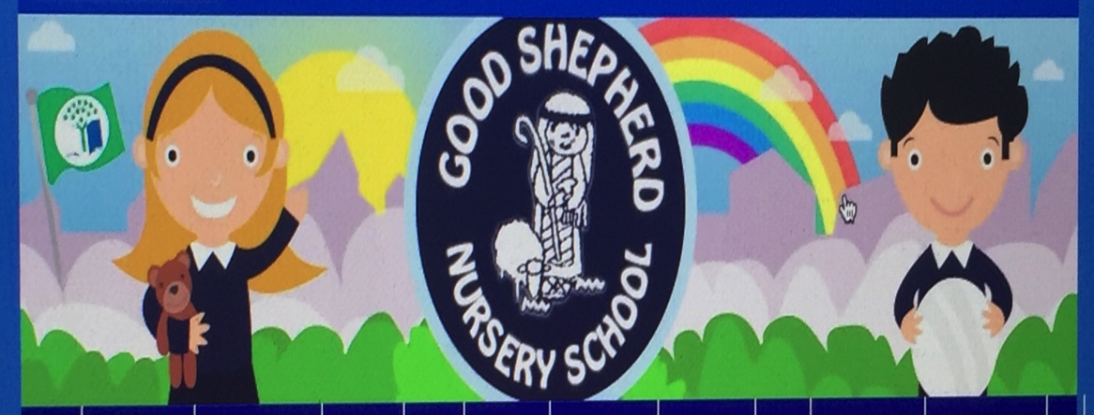
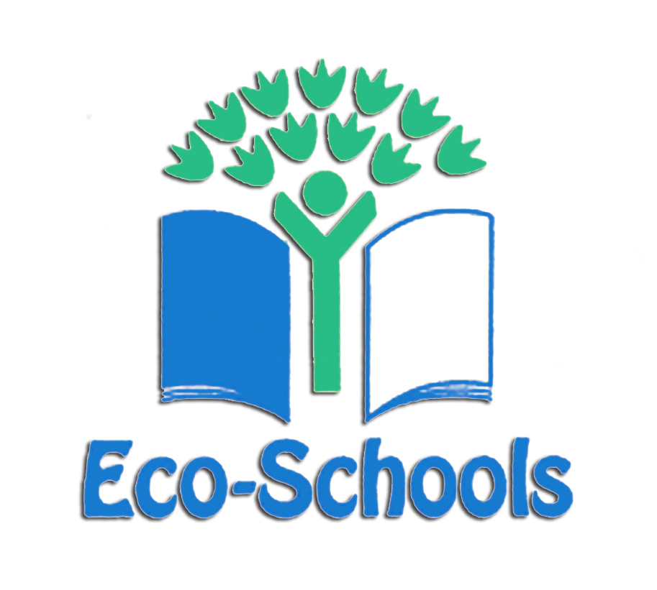

Good Shepherd Nursery School
Eco-school 2020/21
December Eco News

- Our aim for December is to focus on the environment/biodiversity talk about Christmas colours/shapes/Christmas trees/holly/mistletoe/birds/berries for bird/animals that hibernate in winter

- Focus on our garden areas

- Preparing our flower/vegetable beds and planters

- Planting for spring-bulbs-winter flowers

- Discussing Textures and materials, resources relating to Christmas and winter theme

- Explaining about snow fall and how it forms (weather permitting)

- Playing in the snow/ice and watching it melt, weather permitting looking at frost on ground.

- Discussing keeping warm/wearing suitable clothing/footwear.

- Looking forward to the Christmas holiday and keeping safe-celebration

- Preparing to make bird feeders and filling the squirrel boxes before we leave for the holiday

- Taking part in Forest School Programme -Dressing a Tree Day.

- Virtual visit from the Christmas Elf (Belfast City Council ) about recycling

- Use of recycling materials.

