Early Language

Descriptive language is encouraged and enhanced through talking about mixtures,textures, consistencies, smells and tastes of herbs ,flowers and other resources added. Staff will listen to the narrative of the children’s play and expand on this by asking open-ended questions and giving children time to talk about what they are doing and why. Play experiences in this area lend for observations on the ordinary moments and extending Eco opportunities.

Staff will encourage children to work things out, compromise and negotiate when working alongside their friends. Often showing that they can “do” at the same time as listening and talking to others.

Personal, Social & Emotional Development

The children can self-select the items and resources that they need for their play from shelves. They can re-create everyday home scenes in their play which gives a common element that can help them connect with others in the nursery. Sharing stories about home and trips to cafes and restaurants or helping mum/dad will help them to understand concepts.

Work on playing with and alongside others. Sharing, taking turns and problem solving with peers and adults.. Talking about their ideas and considering others ideas as well. Respond to boundaries and safety rules and work out solutions. Considering others’ feeling and choices and having fun in the area.

* 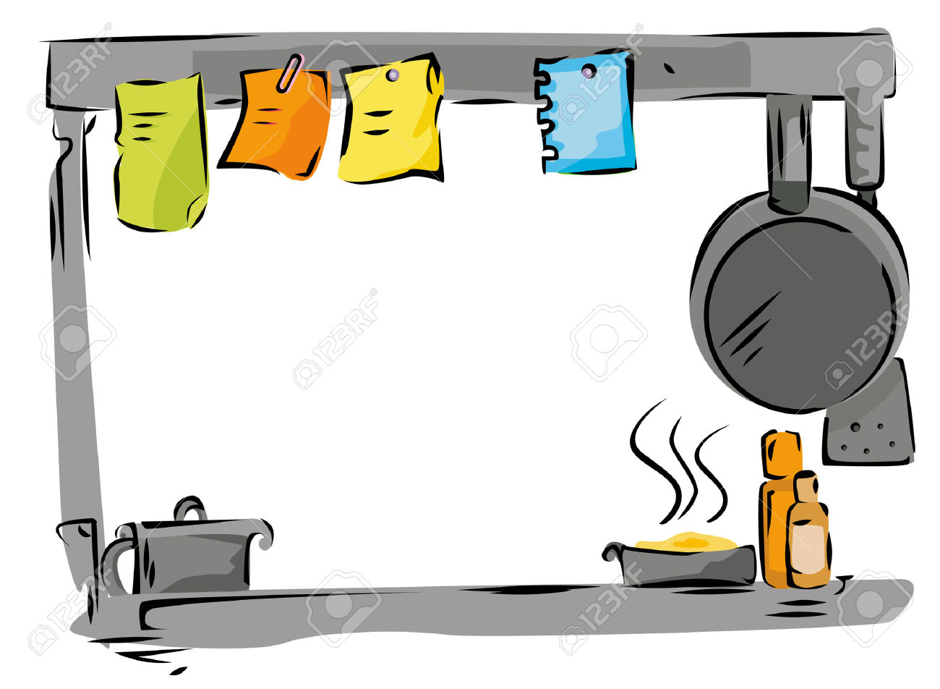

**Physical Development**

* Children will have opportunities to transporting and transfer water and materials using pots, pans, jugs and other containers that are changed regularly. Children will have access to additional resources if they wish to extend play in another direction

Use safe children’s knives to chop spoons to stir, kitchen tongs to pick up things.

* Children will enjoy sensory experiences using damp sand, mud, fresh herbs , water dried rice etc,in a safe and experimental area.

The Arts

Staff will provide and offer opportunities for role play and support children to re-enact what they see in the world around them. Children will copy Parents cooking at home, making cakes, visiting cafes.

* We will focus on the natural loose parts such as pebbles, pinecones and sticks to make art -moveable art.
* Children will use pots, pans and spoons as instruments and make their own music. Staff can add wind chimes to the area and other items that make sounds when weather changes or the wind blows them. Explore the outside environment and make own creations -adding chalk boards, chip boards to encourage creativity in this area. Encourage children to make lists/menus/order, wherever their play takes them.
* 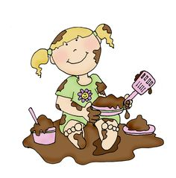

**Maths**

Use tables/shelves to sort,sequence, using measuring tools such as jugs, scales, spoons and cups all easily accessible.

Encourage children to count items as they play with them or use them in their creations. Include lots of loose parts that can be counted. Pebbles, conkers acorns, pinecones and any other natural materials.

Look at sharing out between others in the group. We have 6 conkers and there

Are three children, how many will we all have – encourage children to problem solve.

Allow children to listen and use mathematical language by experimenting, problem solving, making predictions, sorting and matching.

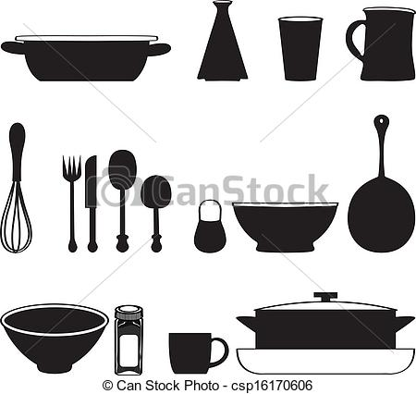



**The World Around Us**

* This area gives children the chance to recreate the things they see happening around them and help
* them to make sense of the world they live in . Provide ethnic resources such as woks, bamboo, rice steamers and other items that will support different cultures as well as introducing new learning to other children –link to Chinese new year in February
* Offer dried foods to this area such as rice, beans, pasta, pulses. The children have the opportunity to explore changes in the seasons and their environment as they use this play space, throughout the year.
* Staff will continue to provide lots of natural materials and resources to consolidate their learning
* 