St Patrick’s Day

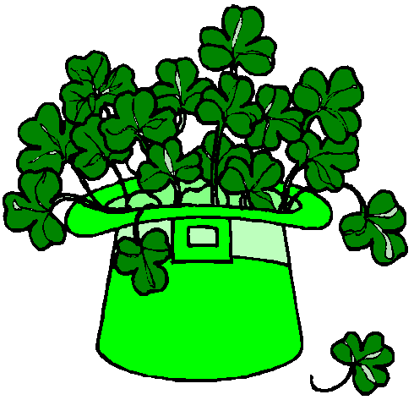
The shamrock is green

The shamrock is green

Hi Ho, St Patrick’s day

The shamrock is green

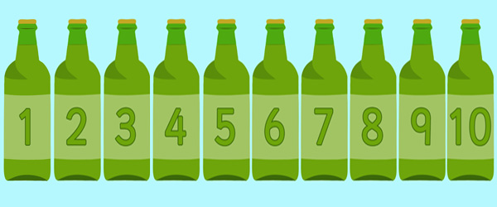

Tune - Ten Green bottles

One green shamrock, in the morning dew,' Another one sprouted, and then there were two.
Two green shamrocks, growing beneath a tree;' Another one sprouted, and then there were three.'
Three green shamrocks, by the cottage door;' Another one sprouted, and then there were four.
Four green shamrocks, near a beehive' Another one sprouted, and then there were five.
Five little shamrocks, bright and emerald green,
“Think of all the luck these shamrocks will bring.”

Tune - I’m a little tea Pot

I`m a little Leprechaun,
dressed in green,
the tiniest man that you have seen,
if you ever catch me, so its told I’ll give you my big pot of gold!

I`m a little Shamrock
see my leaves,
count my petals if you please
if you give me water and lots of sun,
I`ll give you good luck and lots of fun!

Sung ---Bingo
I have a very special friend
and mummy is her name –o.
M-O-M-M-Y, M-O-M-M-Y, M-O-M-M-Y
and Mommy is her name –o.

Prayer

Thank you God for my mummy
and all the things she does for me
and mummy I want you to know
I will always love you so.

