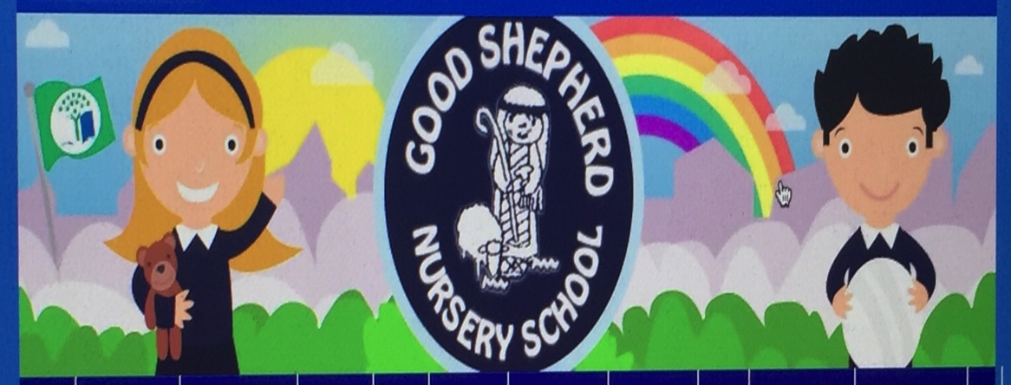
March Art Activities

Green tile paint
Filling Green bottles
Green collage
Green Pepper/vegetable Prints
Green Bubble Painting/Roller Ball
Green Mosaic
Experiment with colour mixing
Drawing patterns onto to clay/dough/plasticine
Experiment with PVA glue
Triangle/shape Sponging
Green/Shamrock Frieze
St Patrick’s Day/Easter/Mother’s Day Art
Shamrocks- Sponge/free
Real Flower painting /Spring Flower Frieze
Flowers from handprints
Flowers using egg cartoons
Painting bare branches
Painting Pets
Junk Art -home and nursery
Free access to art area/natural resources
Reggio emilio theme activities

